**Guidelines for the assignment**

Review these Lectures to aid you on your assignment:

Lecture 3.3.1 - Quality Attributes

Lecture 3.3.2 - Analyzing and Evaluating Architecture

**How to create your assignment?**

We want to evaluate the architecture and design of the given system to determine the future of its development. It is important to identify the risks our system faces that may hinder the end users or developers. Will the end users of our system want to keep using it? Will it be easy and affordable to continue to develop the system? This will reveal issues we may not have known about our system that may be necessary to change in future releases.

Review the Quality Attributes and Analyzing and Evaluating Architecture Lectures to prepare for this assignment. You will need to reference the ATAM Process and Quality Attribute Scenarios.

You are given an Attribute Utility Tree that points out the Architecturally Significant Requirements (ASRs) of the current version of the system. This is an initial Utility Tree we have created for step 5 of the ATAM Process to gain insight about the system and identify the quality priorities that go into the evaluation of our system.

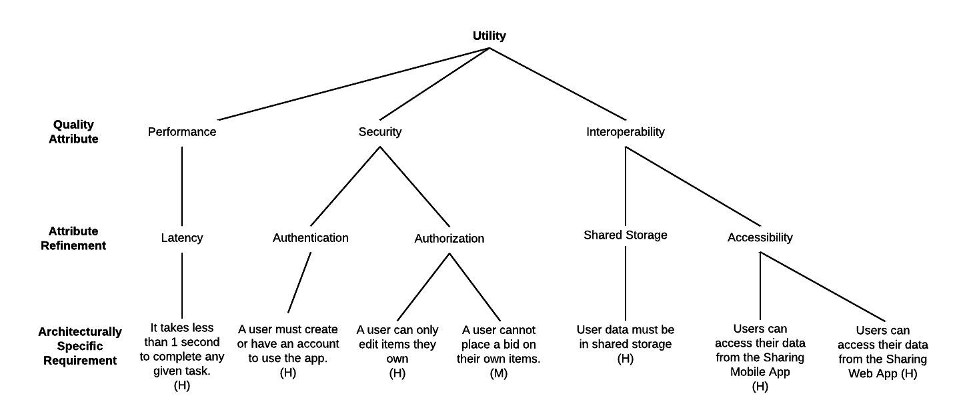

You are also given several Quality Attribute Scenarios, written from various perspectives, to evaluate the architecture of the app.

For each Quality Attribute Scenario provided:

Identify if it is a risk, non-risk, tradeoff, or sensitivity point in the applications architecture and give a brief explanation (3 sentences or less) for each.

This can be put into point form, but each Scenario should be covered.

Update the Utility Tree to reflect the Scenarios. You should be able to make 4-5 changes, including adding a Quality Attribute and adding more Attribute Refinements and ASRs to reflect the risks.

You may also update the current ASRs to reflect the Scenarios or (if justified in the evaluation) change their priorities.

Once you have finished your evaluation, use the Quality Attribute Scenarios to create an updated Utility Tree that considers the Quality Attribute Scenarios based on the primary ASRs from the previous Utility Tree.

Upload a PDF of your updated Utility Tree Diagram and explanations of the Quality Assurance Scenarios.

SOLUTION

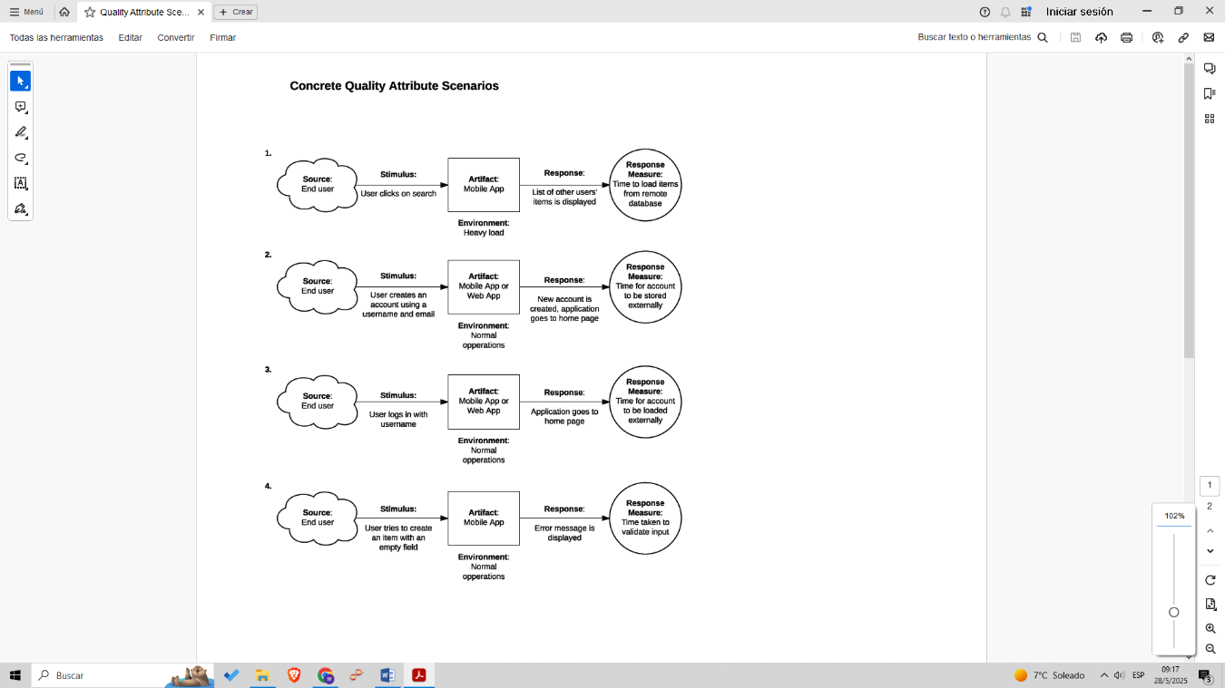

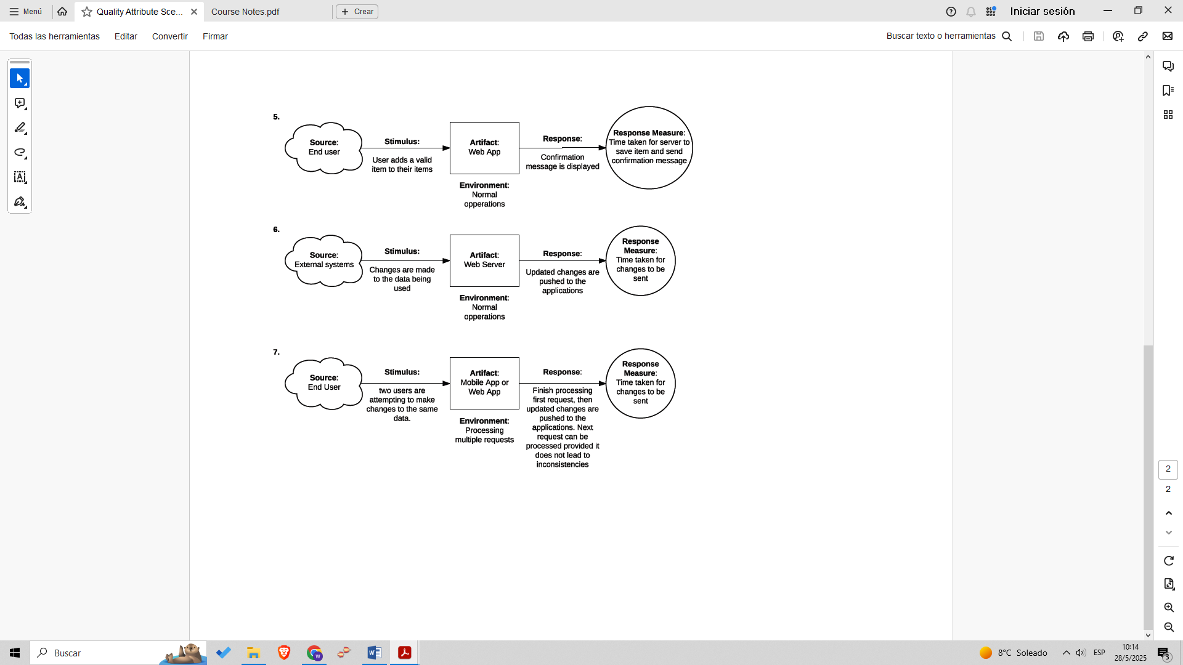

First some definitions:

**Trade-offs** an occurrence when one quality must be sacrificed or

restricted for improvement in another.

**Sensitivity points** Identifies processes in a system that could affect the

specific quality attributes of a system relative to an ASR.

SCENARIOS

1. **Sensitivity Point**: Because the environment is “heavy load,” the latency quality attribute may be affected. This scenario represents a sensitivity point for the performance quality attribute.
2. **Non-Risk**: This is a normal scenario—everything operates correctly.
3. **Non-Risk**: Identical to the previous scenario.
4. **Trade-off**: We sacrifice latency in order to validate the input field (usability). Since “usability” isn’t represented in the tree, it should be added.
5. **Non-Risk**: Everything operates correctly.
6. **Risk**: Changes to the data may originate from unregistered external systems or unauthenticated users. It’s unclear whether they should have access, which poses a security risk.
7. **Trade-off**: We sacrifice latency for the user who issues the second request in order to guarantee consistency.

UPDATED TREE